using the attached csv file, Design a new schema in 3NF.
Customers table (CustomerID, FirstName, LastName, Email, etc.).
Products table (ProductID, Name, Price, CategoryID).
Categories table (CategoryID, CategoryName).
Orders table (OrderID, CustomerID, OrderDate).
OrderItems table (OrderItemID, OrderID, ProductID, Quantity) to handle the many-to-many relationship between orders and products.

Based on the data in the gadgetgo.csv spreadsheet, here are the distinct entities identified:
1. Distinct Customers
There are 7 unique customers in the system:
- Amelia Taylor: amelia.taylor@gmail.com
- Emily Johnson: emily.johnson@yahoo.co.uk
- Harry Wilson: harry.wilson@hotmail.co.uk
- Jack Thompson: jack.thompson@yahoo.co.uk
- James Smith: james.smith@gmail.com
- Oliver Brown: oliver.brown@outlook.com
- Sophia Williams: sophia.williams@gmail.com
2. Distinct Products
There are 8 unique products listed:
- Bluetooth Headphones: $59.99
- Laptop Backpack: $49.99
- Mechanical Keyboard: $89.99
- Noise Cancelling Earbuds: $79.99
- Smartphone Stand: $14.99
- Tablet Cover: $29.99
- USB-C Charger: $19.99
- Wireless Mouse: $25.99
3. Distinct Orders
There are 7 unique orders recorded:
- ORD001: 2024-01-05
- ORD002: 2024-01-08
- ORD003: 2024-01-10
- ORD004: 2024-01-12
- ORD005: 2024-01-15
- ORD006: 2024-01-18
- ORD007: 2024-01-20
4. Distinct Product Categories
The products are categorized using 8 unique tags:
- Accessories
- Audio
- Bags
- Computer Accessories
- Electronics
- Mobile Accessories
- Office
- Tablet Accessories

Based on the data provided in gadgetgo.csv, here is the redesigned database schema in Third Normal Form (3NF).
The original flat file was normalized to remove data redundancy and ensure data integrity. The complex ProductCategories strings were decomposed, and customer names were split to meet standard database conventions.
1. Database Schema Design (3NF)
Customers Table
Stores unique customer information.
- CustomerID (PK, int): Unique identifier for each customer.
- FirstName (varchar): Customer's first name.
- LastName (varchar): Customer's last name.
- Email (varchar): Unique email address.
- Address (varchar): Billing/Shipping address.
Categories Table
Contains the distinct product categories found in the system.
- CategoryID (PK, int): Unique identifier for the category.
- CategoryName (varchar): Name of the category (e.g., Electronics, Audio).
Products Table
Stores details for each item sold. Each product is linked to a primary category.
- ProductID (PK, int): Unique identifier for the product.
- Name (varchar): Product name.
- Price (decimal): Unit price of the product.
- CategoryID (FK, int): Reference to the primary category in the Categories table.
Orders Table
Records high-level transaction data.
- OrderID (PK, varchar): The unique order number (e.g., ORD001).
- CustomerID (FK, int): Reference to the customer who placed the order.
- OrderDate (date): Date the transaction occurred.
OrderItems Table
The junction table handling the many-to-many relationship between Orders and Products.
- OrderItemID (PK, int): Unique identifier for the line item.
- OrderID (FK, varchar): Reference to the specific order.
- ProductID (FK, int): Reference to the product purchased.
- Quantity (int): Number of units purchased in this specific order.

2. SQL DDL Statements
You can use the following SQL script to create this schema:
SQL
-- Create Categories Table
CREATE TABLE Categories (
CategoryID INT PRIMARY KEY,
CategoryName VARCHAR(100)
);

-- Create Customers Table
CREATE TABLE Customers (
CustomerID INT PRIMARY KEY,
FirstName VARCHAR(100),
LastName VARCHAR(100),
Email VARCHAR(255) UNIQUE,
Address TEXT
);

-- Create Products Table
CREATE TABLE Products (
ProductID INT PRIMARY KEY,
Name VARCHAR(255),
Price DECIMAL(10, 2),
CategoryID INT,
FOREIGN KEY (CategoryID) REFERENCES Categories(CategoryID)
);

-- Create Orders Table
CREATE TABLE Orders (
OrderID VARCHAR(50) PRIMARY KEY,
CustomerID INT,
OrderDate DATE,
FOREIGN KEY (CustomerID) REFERENCES Customers(CustomerID)
);

-- Create OrderItems Table
CREATE TABLE OrderItems (
OrderItemID INT PRIMARY KEY,
OrderID VARCHAR(50),
ProductID INT,
Quantity INT,
FOREIGN KEY (OrderID) REFERENCES Orders(OrderID),
FOREIGN KEY (ProductID) REFERENCES Products(ProductID)
);

for attached spreadsheet, Propose writing a script to migrate the data from the spreadsheet into the new, clean database structure in a beginner friendly manner.

To migrate data from a single "flat" spreadsheet like gadgetgo.csv into a clean, professional database (3NF), we need a script that acts as a translator. This process is called ETL (Extract, Transform, Load).
The Migration Plan
Think of the spreadsheet as one big messy box of toys. The migration script will:
- Clean the Box: Fix formatting errors in the file.
- Sort the Toys: Separate the data into "piles" for Customers, Products, and Categories.
- Label Everything: Assign unique ID numbers (Primary Keys) so the database can keep track of items.
- Connect the Dots: Create the links (Foreign Keys) between orders and the people who placed them.

The Migration Script (Python)
You can run this script using a tool like VS Code or a Jupyter Notebook. It uses the pandas library, which is the industry standard for handling data.
Python
import pandas as pd

# STEP 1: Load the messy spreadsheet
df = pd.read_csv('gadgetgo.csv')

# STEP 2: Create the "Categories" table
# We find every unique category name (like 'Electronics' or 'Audio')
all_cats = set()
for cat_str in df['ProductCategories'].dropna().unique():
for c in cat_str.split(';'):
all_cats.add(c.strip())

categories_df = pd.DataFrame(sorted(list(all_cats)), columns=['CategoryName'])
categories_df['CategoryID'] = range(1, len(categories_df) + 1)

# STEP 3: Create the "Customers" table
# We extract unique names and emails, then split 'James Smith' into 'James' and 'Smith'
customers_df = df[['CustomerFullName', 'CustomerEmail', 'CustomerAddress']].drop_duplicates(subset=['CustomerEmail']).copy()
customers_df['CustomerID'] = range(1, len(customers_df) + 1)
customers_df[['FirstName', 'LastName']] = customers_df['CustomerFullName'].str.split(' ', n=1, expand=True)
customers_final = customers_df[['CustomerID', 'FirstName', 'LastName', 'CustomerEmail', 'CustomerAddress']]

# STEP 4: Create the "Products" table
# We list each unique product and link it to its Category ID
products_df = df[['ProductName', 'ProductPrice', 'ProductCategories']].drop_duplicates(subset=['ProductName']).copy()
products_df['ProductID'] = range(1, len(products_df) + 1)
# Mapping logic to find the right ID
cat_map = categories_df.set_index('CategoryName')['CategoryID'].to_dict()
products_df['CategoryID'] = products_df['ProductCategories'].apply(lambda x: cat_map[x.split(';')[0].strip()])
products_final = products_df[['ProductID', 'ProductName', 'ProductPrice', 'CategoryID']]

# STEP 5: Create the "Orders" and "OrderItems" tables
# Finally, we link the Order IDs to the Customer IDs we just created
cust_map = customers_final.set_index('CustomerEmail')['CustomerID'].to_dict()
df['CustomerID'] = df['CustomerEmail'].map(cust_map)
orders_final = df[['OrderID', 'CustomerID', 'OrderDate']].drop_duplicates()

prod_map = products_final.set_index('ProductName')['ProductID'].to_dict()
df['ProductID'] = df['ProductName'].map(prod_map)
order_items_final = df[['OrderID', 'ProductID', 'Quantity']].reset_index(names='OrderItemID')

# STEP 6: Save the results into clean, individual files
customers_final.to_csv('customers.csv', index=False)
products_final.to_csv('products.csv', index=False)
categories_df.to_csv('categories.csv', index=False)
orders_final.to_csv('orders.csv', index=False)
order_items_final.to_csv('order_items.csv', index=False)

print("Migration Complete! Your clean database files are ready.")

Why this is "Clean" (3NF)
- No Duplicates: Instead of repeating "James Smith" and his address for every single item he bought, we store him once in the Customers table.
- Easy Updates: If the price of the "Wireless Mouse" changes, you only update it in the Products table once, and every order automatically sees the new price.
- Atomic Data: We split full names into FirstName and LastName, making it much easier to sort or send personalized emails like "Hi James!".
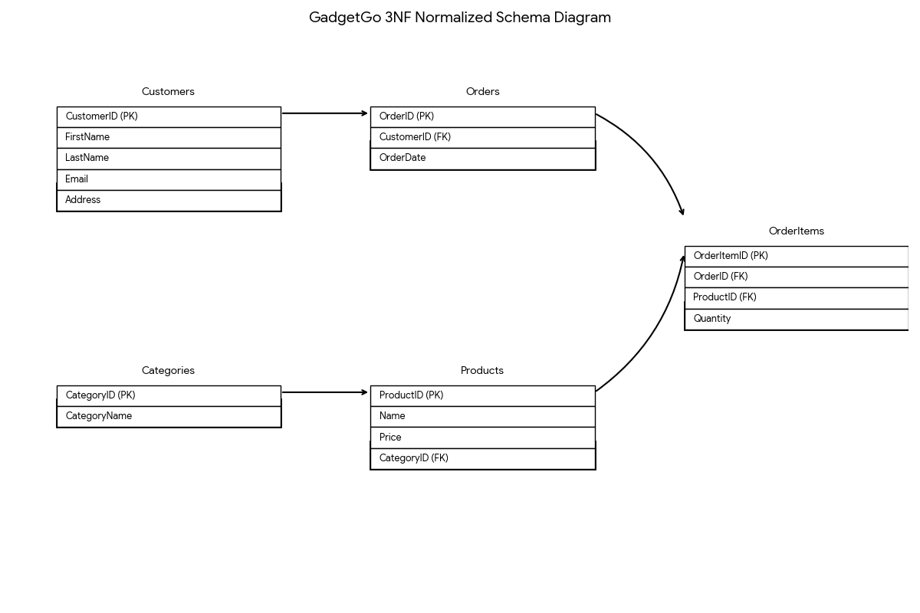
Here is the 3NF (Third Normal Form) Normalized Schema Diagram for the GadgetGo database.
3NF Schema Overview
The diagram illustrates how the original flat data from the spreadsheet has been decomposed into five distinct tables to eliminate redundancy and ensure data integrity.
- Customers: Stores personal details. Each customer is unique and identified by a CustomerID.
- Categories: A lookup table for product types. This prevents the same category name from being typed differently across products.
- Products: Contains individual items. It links to a CategoryID instead of storing the category name directly.
- Orders: Captures the high-level transaction (Who bought it and when). It links to Customers.
- OrderItems: The "Line Items" of the order. This table resolves the many-to-many relationship between Orders and Products, allowing one order to contain multiple different products and quantities.
Key Relationships
- Customers (1) $\rightarrow$ Orders (N): One customer can place many orders.
- Categories (1) $\rightarrow$ Products (N): One category can contain many different products.
- Orders (1) $\rightarrow$ OrderItems (N): One order can contain multiple line items.
- Products (1) $\rightarrow$ OrderItems (N): A single product can appear in many different orders.
This structure ensures that if a customer changes their address or a product changes its price, you only need to update it in one place.

VS code:
-- Create Categories Table
CREATE TABLE Categories (
CategoryID INT PRIMARY KEY,
CategoryName VARCHAR(100)
);

-- Create Customers Table
CREATE TABLE Customers (
CustomerID INT PRIMARY KEY,
FirstName VARCHAR(100),
LastName VARCHAR(100),
Email VARCHAR(255) UNIQUE,
Address TEXT
);

-- Create Products Table
CREATE TABLE Products (
ProductID INT PRIMARY KEY,
Name VARCHAR(255),
Price DECIMAL(10, 2),
CategoryID INT,
FOREIGN KEY (CategoryID) REFERENCES Categories(CategoryID)
);

-- Create Orders Table
CREATE TABLE Orders (
OrderID VARCHAR(50) PRIMARY KEY,
CustomerID INT,
OrderDate DATE,
FOREIGN KEY (CustomerID) REFERENCES Customers(CustomerID)
);

-- Create OrderItems Table
CREATE TABLE OrderItems (
OrderItemID INT PRIMARY KEY,
OrderID VARCHAR(50),
ProductID INT,
Quantity INT,
FOREIGN KEY (OrderID) REFERENCES Orders(OrderID),
FOREIGN KEY (ProductID) REFERENCES Products(ProductID)
);

-- Insert Products (Linked to Categories)
INSERT INTO Products (ProductID, Name, Price, CategoryID) VALUES
(501, 'Laptop', 999.99, 1),
(502, 'Coffee Maker', 49.50, 2),
(503, 'SQL Basics Guide', 29.99, 3),
(504, 'Smartphone', 699.00, 1);

-- Insert Orders (Linked to Customers)
INSERT INTO Orders (OrderID, CustomerID, OrderDate) VALUES
('ORD-001', 101, '2023-10-01'),
('ORD-002', 102, '2023-10-02'),
('ORD-003', 101, '2023-10-03');

-- Insert OrderItems (Links Orders to Products)
INSERT INTO OrderItems (OrderItemID, OrderID, ProductID, Quantity) VALUES
(1, 'ORD-001', 501, 1), -- Alice bought a Laptop
(2, 'ORD-001', 503, 2), -- Alice also bought 2 SQL books
(3, 'ORD-002', 502, 1), -- Bob bought a Coffee Maker
(4, 'ORD-003', 504, 1); -- Alice bought a Smartphone

-- Insert Categories
INSERT INTO Categories (CategoryID, CategoryName) VALUES
(1, 'Electronics'),
(2, 'Home Appliances'),
(3, 'Books');

-- Insert Customers
INSERT INTO Customers (CustomerID, FirstName, LastName, Email, Address) VALUES
(101, 'Alice', 'Smith', 'alice.s@example.com', '123 Maple St, Springfield'),
(102, 'Bob', 'Johnson', 'bjohnson@example.com', '456 Oak Ave, Metropolis'),
(103, 'Charlie', 'Davis', 'charlie.d@example.com', '789 Pine Rd, Gotham');

select * from Customers;
select * from Categories;
select * from OrderItems;
select * from Orders;
select * from Products;

Level 1 DFD:
Model the Data Flow: provide the code for plantuml for a Level 1 DFD showing processes like 'User Registration', 'Browse Products', and 'Place Order'. The DFD's data stores (Customers, Products, Orders) will directly map to the new schema in a beginner friendly manner.
To visualize how data moves between your users, the processes, and your database tables, a Level 1 Data Flow Diagram (DFD) is the perfect tool.
In a Level 1 DFD:
- Entities (Square) are the external actors (the User).
- Processes (Circle/Round Box) are the actions being taken.
- Data Stores (Open Rectangle) represent your SQL tables
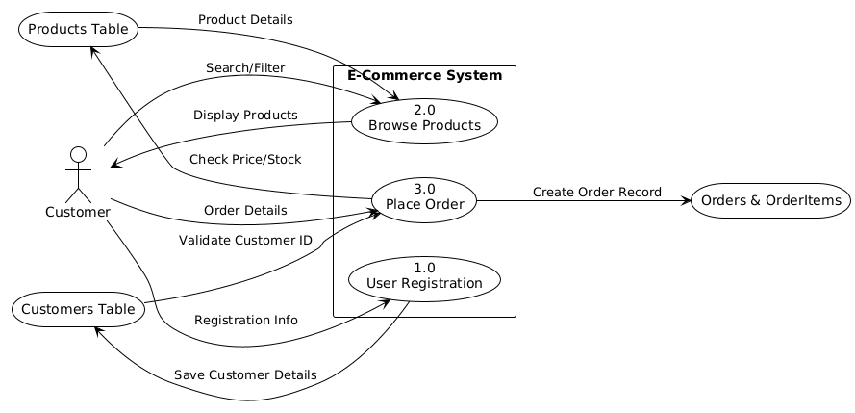
Mapping the DFD to your SQL Schema
To keep this beginner-friendly, here is how the "Data Flows" in the diagram translate to the SQL tables you just created:
DFD Process | Action | SQL Table Involved | Key Columns Used
User Registration | INSERT | Customers | CustomerID, Email
Browse Products | SELECT | Products, Categories | Name, Price, CategoryName
Place Order | INSERT | Orders, OrderItems | OrderID, ProductID, Quantity
How to read this flow:
- Registration: The user provides data that moves into the Customers data store.
- Browsing: Data flows out of the Products data store to the user so they can see what is available.
- Place Order: This is the most complex flow. It takes the CustomerID from the Customers table and the ProductID from the Products table to create new entries in the Orders and OrderItems tables.

